

A PROJECT REPORT

ON

STUDENT RESULT MANAGEMENT SYSTEM

DONE BY

Snehal A. Yadav

(EBTSOC0920316820)

Under the Guidance of,

**Mr. V JAYANTH**

**Technical Trainer**

**NASSCOM PROJECT**

**­**

**ARISE**

**ONCAMPUS**

**SOFTWARE DEVELOPER TRAINEE**

Tambaram, Chennai-600045 (Tamil Nadu)­­

2020

**TABLE OF CONTENT**

**S. TITLE PAGE**

**NO**

ABSTRACT 4

**1. INTRODUCTION TO THE STUDY** 5

1.1 Iintroduction 5

1.2 Definition of the Problem 5

1.3 System Requirement 6

* Hardware Requirement
* Software Requirement

**2. AIMS & OBJECTIVES OF THE STUDY 7**

2.1 Objective

2.2 Goals

**3. LITRATURE REVIEW 8**

**4. RESEARCH METHODOLOGY 10**

4.1 Planning 10

4.2 System Architecture 11

* Activity Diagram
* Data Flow Diagram

**5. SYSTEM DESIGN 14**

5.1 System Study 14

· Feasibility Study

5.2 Input Design 15

5.3 Output Design 15

**6. SYSTEM ANALYSIS 14**

6.1 Advantages

6.2 Outcome

6.3 Application

**7. CONCLUSION 17**

**8. REFERENCE 17**

**APPENDIX-I**

* **SNAPSHOTS 18**

**ABSTRACT**

The purpose of Student Result Management System is to automate the existing manual system by the help of computerized equipment and full-fledged computer

Software, fulfilling their requirements, so their valuable data/information can be

Stored for a longer period with easy accessing and manipulation of the same. The required software and hardware are easily available and easy to work with.

Student Result Management System, as described above, can lead to error free

Secure, reliable and fast management system. It can assist the user to concentrate on

Their other activities rather to concentrate on record keeping. Thus, it will help organization in better utilization of resources. The organization can maintain computerized records without redundant entries. That means that one need not be distracted by information that is not relevant, while being able to reach the information.

The aim is to automate its existing manual system by help of computerized equipment and full-fledged computer system, fulfilling their requirements, so that their valuable date/information can be stored for a longer period with easy accessing and manipulation of the same. Basically, the project described how to manage for good performance and better service for the clients.

**CHAPTER – 1**

1. **INTRODUCTION TO THE STUDY**

**1.1 INTRODUCTION:**

The “Student Result Management System” has been developed to override the problems prevailing in the practicing manual system. This software is supported to eliminate and inn some case reduces the hardships faced by this existing system. Moreover, this system is designed for the particular need of the company to carry out operations in the smooth and effective manner.

The application is reduced as much as possible to avoid errors while entering the data.

It also provides error message while entering invalid data. No formal knowledge is needed for the user to use this system. Thus by this all it proves it is user-friendly. Student Result Management System as described above as can lead to error free, secure reliable and fast Management System. It can assist the user to concentrate on their other activities rather to concentrate on record keeping. Thus, it will help organization in better utilization of resources.

Every organization, whether big or small, has challenges to overcome and managing the information of Result, Student, Class, Student semester. Every Student Result Management System has different Student needs. Therefor we design exclusive employee management system that adopted to your management requirement. This is designed to assist in strategic planning and will help you ensure that your organization is equipped with the right level of information and details of your future goals. Also, for those buy exclusive who are always on the go, our systems come with remote access feature, which will allow you to manage your workforce anytime, at all times. These systems ultimately allow you to better manage resources.

**1.2 DEFINITION OF PROBLEM:**

Currently, the process of declaring and managing the students’ results is performed manually with extensive human intervention. The students’ results are generated through a spreadsheet application and then printed on a paper, attached to a wall for declaration and then stored. Despite having an application that generates the result, it is not very effective as the system consumes a lot of time and human resources in performing various tasks, it is costly, it lacks data security and efficiency. And at present, the institution needs an advanced and computerized environment. And once implemented, it will minimize all the problems mentioned.

**1.3 SYSTEM REQUIREMENT:**

* **Hardware Requirements:**
* System : Pentium IV 2.4 GHz.
* Hard Disk : 40 GB.
* Floppy Drive : 1.44 Mb.
* Monitor : 15 VGA Colour.
* Mouse : Logitech.
* Ram : 512 Mb.
* **Software Requirements:**
* Operating system : Windows XP/10.
* Coding Language : JAVA.
* IDE : eclipse.
* Database : MYSQL.

**CHAPTER – 2**

1. **OBJECTIVES & GOALS OF THE STUDY**

**2.1 OBJECTIVE:**

The main objective of the project on Student Result Management System is to manage the details of Student, Result, Subject, Class, Semester. It manages all the information about Student, Subject, Semester. The project is totally built at administrative end and thus only the administrator is guarantee the access. The purpose of the project is to build an application program to reduce the manual work

For managing the student, subject. It tracks all the details above the subject, class, semester.

**2.2 GOALS:**

* Provides the searching facilities based on various factors. Such as Student.
* Student Result Management System also manages the Subject details online for class details, semester details, Student.
* It tracks all the information for result, Subject, Class etc.
* Manages the information of result.
* Shows the information and description of the Student, Result.
* To increase efficiency of managing the Student, Result.
* It deals with monitoring the information and transaction of class.
* Manage the information of Student.
* Editing, adding and updating of records is improved which is proper resource management of student data.
* Manage the information of class.
* Integration of all records of Semester.

**CHAPTER – 3**

1. **LITERATURE REVIEW**

According to Freund et al. (2017), nowadays people interact directly with technology in fields such as education, government, finance, retail, entertainment, health care, science, travel, publishing, and manufacturing.

And they also state that, educators and teaching institutions use technology to assist with education. Most equip labs and classrooms with laptops or desktops. Some even provide computers or mobile devices to students. Many require students to have a mobile computer or mobile device to access the school’s network or Internet wirelessly, or to access digital-only content provided by a textbook publisher.

And educators may use a Course Management System (CMS), sometimes called a Learning Management System (LMS), which is a software that contains tools for class preparation, distribution, and management. For example, through the course management system, students access course materials, grades, assessments, and a variety of collaboration tools.

Many schools offer distance learning classes, where the delivery of education occurs at one place while the learning occurs at other locations. Distance learning courses provide time, distance, and place advantages for students who live far from a campus or work full time. Referencing Wallace (2015), the LMS is an information system used to track student progress, and manage educational records. Many offer other features, such as online registration, assessment tools, collaborative technologies, and payment processing. They also offer tools for creating or importing content.

And she also states that, people are so accustomed to social networking and other web applications that it is an easy step to build these tools into an online platform or environment. And referencing (2015), LMS characterizes a complex, often web based software system which pools multiple task specific subprograms under a shared User Interface (UI).

These subprograms support, for instance:

• Allocation and organization of learning content for different learning scenarios;

• School administration;

• Information management;

• Online school business related communication.

**3.1 Learning Management System Features**

Dias (2014) state that, LMS Moodle (Modular Object-Oriented Dynamic Learning Environment), a free and open-source platform based on socio constructivist perspectives developed in 1999, allows users to incorporate various resources and functionalities in a modular structure. Additionally, seen as a Course Management System (CMS), Moodle can be used to manage the students’ path, to monitor their performance, to create and distribute content, to organize e-activities, to evaluate, as well as to provide tools for communication, collaboration and interaction between the peers involved in the educational process.

However, it is important to underline that incorporation of a wide range of activities in the LMS per se does not seem sufficient to enhance the teaching learning process. These kind of learning platforms (e.g., Blackboard, Moodle, WebCT) should be seen as an opportunity for institutions to develop learning materials, online courses, tests and evaluations, databases and to online monitor students’ progress.

Furthermore (2015) states that, an LMS also has to represent a number of characteristics to satisfy the stakeholders’ needs:

• User friendly, intuitive design and self-explanatory functionalities;

• Adequacy for the users’ levels of experience and knowledge;

• High system robustness against data-loss or system failure;

• High data security standards;

• Easy accessibility;

• System flexibility for institutions’ individual configurations and concept adaptations. According to Foreman (2018), an LMS differs from other information systems and it has its own features that allows schools and institutions to manage users and courses and administer the system.

• The user management features of an LMS include user account creation, authentication, user profiles, and roles and permissions.

• The course management includes managing lessons and assignments, post a course syllabus, learning goals, and schedule, provide interactive activities such as surveys, quizzes, and polls, upload and download multimedia course materials, conduct web conferences, send instructor-student messages and messages among students and establish student groups.

• The academic features are those that require special permission and, generally, are not accessible to students. They include class rosters and gradebooks, reports, analytics and statistics, and tools for developing courses and lessons in the system. Moreover, the current research focuses on the section where the professors and students are registered into the system and are enrolled in respective subjects, allowing the professors, to grade the students and monitor their progress. And allows the students to view their own progress or results on each enrolled course.

**CHAPTER – 4**

1. **RESEARCH METHODOLOGY**

**4.1 PLANNING:**

Plan on starting or continuing with an activity and define the activities.



Figure 4.1.1: Activity Diagram

Activity diagrams are graphical representations of workﬂows of stepwise activities and actions with support for choice, iteration and concurrency. In the Uniﬁed Modeling Language, activity diagrams can be used to describe the business and operational step-by-step workﬂows of components in a system. An activity diagram shows the overall ﬂow of control. A use case diagram in the Uniﬁed Modeling Language (UML) is a type of behavioral diagram deﬁned by and created from a Use-case analysis. Its purpose is to present a graphical overview of the functionality provided by a system in terms of factors, their goals (represented as use cases), and any dependencies between those use cases. The main purpose of a use case diagram is to show what system functions are performed for which actor. Roles of the actors in the system can be depicted.

Use Case View Use Case Diagram. Example is given below

* Captures system functionality as seen by users
* Built in early stages of development
* Developed by analysts and domain experts
* System behavior, that is what functionality it must provide, is documented in a use case model.

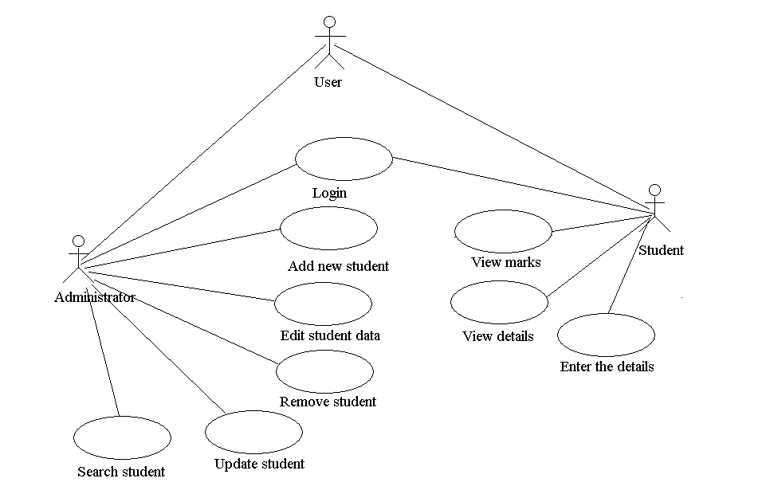

Figure 4.1.2: Use case Diagram

* 1. **SYSTEM ARCHITECTURE:**
* **Data Flow Diagram:**

1. The DFD is also called as bubble chart. It is a simple graphical formalism that can be used to represent a system in terms of input data to the system, various processing carried out on this data, and the output data is generated by this system.

2. The data ﬂow diagram (DFD) is one of the most important modeling tools. It is used to model the system components. These components are the system process, the data used by the process, an external entity that interacts with the system and the information ﬂows in the system.

3. DFDs how show the information moves through the system and how it is modiﬁed by a series of transformations. It is a graphical technique that depicts information ﬂow and the transformations that are applied as data moves from input to output. 4. DFD is also known as bubble chart. A DFD may be used to represent a system at any level of abstraction. DFD may be partitioned into levels that represent increasing information ﬂow and functional detail.

User

Report

Figure 4.2.1: Level 0 Data Flow Diagram

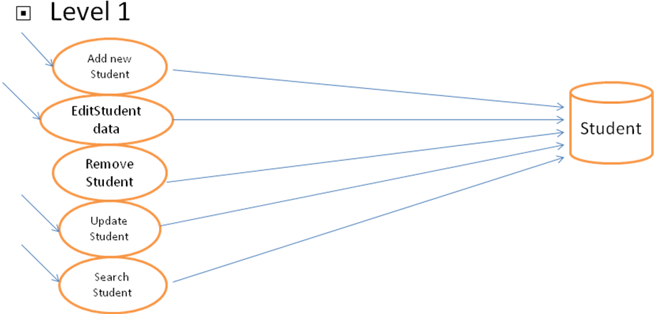

Figure 4.2.2: Level 1 Data Flow Diagram

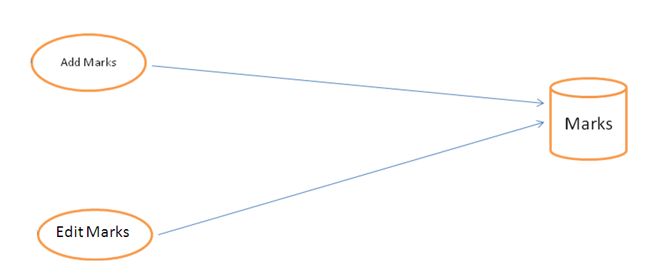

Figure 4.2.3: Level 1 Data Flow Diagram

**CHAPTER – 5**

1. **SYSTEM DESIGN**

**5.1 SYSTEM STUDY:**

* **Feasibility Study:**

The feasibility of the project is analyzed in this phase and business proposal is put forth with a very general plan for the project and some cost estimates. During system analysis the feasibility study of the proposed system is to be carried out. This is to ensure that the proposed system is not a burden to the company. For feasibility analysis, some understanding of the major requirements for the system is essential.

Three key considerations involved in the feasibility analysis are

* **ECONOMICAL FEASIBILITY:**

This study is carried out to check the economic impact that the system will have on the organization. The amount of fund that the company can pour into the research and development of the system is limited. The expenditures must be justified. Thus, the developed system as well within the budget and this was achieved because most of the technologies used are freely available. Only the customized products had to be purchased.

* **TECHNICAL FEASIBILITY**

This study is carried out to check the technical feasibility, that is, the technical requirements of the system. Any system developed must not have a high demand on the available technical resources. This will lead to high demands on the available technical resources. This will lead to high demands being placed on the client. The developed system must have a modest requirement, as only minimal or null changes are required for implementing this system.

* **SOCIAL FEASIBILITY**

The aspect of study is to check the level of acceptance of the system by the user. This includes the process of training the user to use the system efficiently. The user must not feel threatened by the system, instead must accept it as a necessity. The level of acceptance by the users solely depends on the methods that are employed to educate the user about the system and to make him familiar with it. His level of confidence must be raised so that he is also able to make some constructive criticism, which is welcomed, as he is the final user of the system.

**5.2 INPUT DESIGN:**

The input design is the link between the information system and the user. It comprises the developing specification and procedures for data preparation and those steps are necessary to put transaction data in to a usable form for processing can be achieved by inspecting the computer to read data from a document or it can occur by having people keying the data directly into the system.

**Input:** The admin will enter the student details & marks of student in every subject.

**5.3 OUTPUT DESIGN:**

A quality output is one, which meets the requirements of the end user and presents the information clearly. In any system results of processing are communicated to the users and to other system through outputs. In output design it is determined how the information is to be displaced for immediate need and also the hard copy output. It is the most important and direct source information to the user. Efficient and intelligent output design improves the system’s relationship to help causer decision-making.

**Output:** Student will get marksheet along with calculated result which can be downloaded or we can take print of it.

**CHAPTER – 6**

1. **SYSTEM ANALYSIS**

**6.1 ADVANTAGES:**

* **Quicker delivery of results:**

Answer sheet evaluation and scoring happen instantly in the online result system allowing for quicker rank list generation

* **Accurate results**

Reduced human intervention brings down chances of errors, and hence, the results delivered by the student mark analysis system tend to be accurate.

* **Analytics**

Clear and thorough analysis of results leads to a comprehensive report generation which is useful for all the stakeholders involved, including teachers, administrators and students.

* **Bias-free checking**

Reduced or nil human intervention in the student examination result processing system also makes it free from personal biases and prejudices, thereby delivering reliable, accurate and valid results.

* **Transparency**

Digitization of the entire process makes the student result processing system transparent and objective.

**6.2 OUTCOME:**

* We can update all the information in the system.
* Any user can access this system easily.
* We can see all the information regarding to marks.
* We can save the marksheet in PDF format or can take print of it.

**6.3 APPLICATIONS:**

* Educational institutes & Universities

1. **CONCLUSION**

The present research was based on the computerization and the implementation of a sophisticated Student Result Management System. The main objective was to enhance and automate the management and declaration of students’ results using a computerized system. A well-defined, efficient, controlled and managed information system or software based on web technology storing, processing and providing information through the internet. And the objectives were achieved by following a process model such as system analysis, design and system implementation. The system analysis was composed of two activities, requirement determination and structuring. The first activity focused on the collection of data or requirements through structured interview, work environment observation and by collecting procedures and other written documents. And the latter, performed the modelling of the collected data and processes, transforming it into UML diagrams with the aid of a UML modelling tool into a graphically understandable manner. Just as structured analysis uses DFDs (Data Flow Diagrams) to model data and processes, systems analysts use UML to describe Object Oriented systems, on which the current system is based. UML is independent of any specific programming language and can be used to describe business processes and requirements generally. Finally, the implementation or coding of the proposed system was based on the software architecture standard, MVC using Java programming language, which is based on the object-oriented paradigm.

1. **REFERENCE**

**[1]** Herbert Scheldt, **Java Complete Reference**, Fifth Edition, Tata McGraw Hill Edition.

**[2]** Phil Hanna, **JSP 2.0**: The Complete Reference, Tata McGraw Hill Edition, 2003.

**[3]** Elmarsi and Navathe, **Fundamentals of Database System** (Third Edition), Addision

Wesley.

**[4]** Ian Somerville, **Software Engineering**, Third Edition, Pearson Education.

**[5]** Ali Bahrami, **Object-Oriented System Development**, Third Edition, Tata McGraw

Hill Edition.

**[6]** Ivan Bayross, **SQL, PL/SQL programming language of Oracle,** Second Edition,

BPB Publication.

**WEB REFERENCES**

**[1] www.google.com**

**[2] www.htmlcodetutorial.com**

**SNAPSHOTS**

**HOME PAGE:**

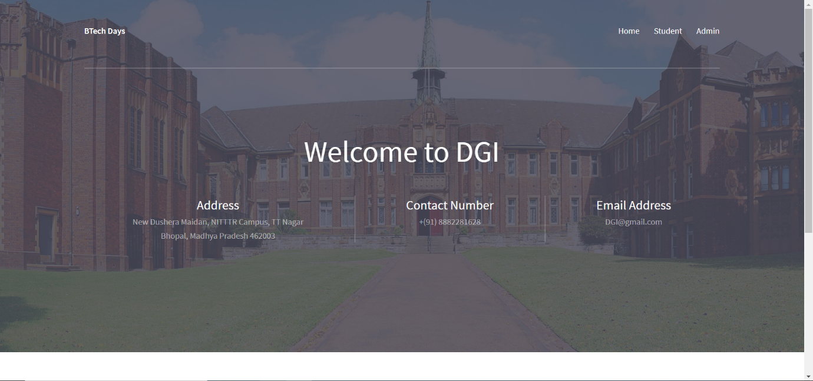

**ADMIN LOGIN:**



**ADD NEW STUDENT:**

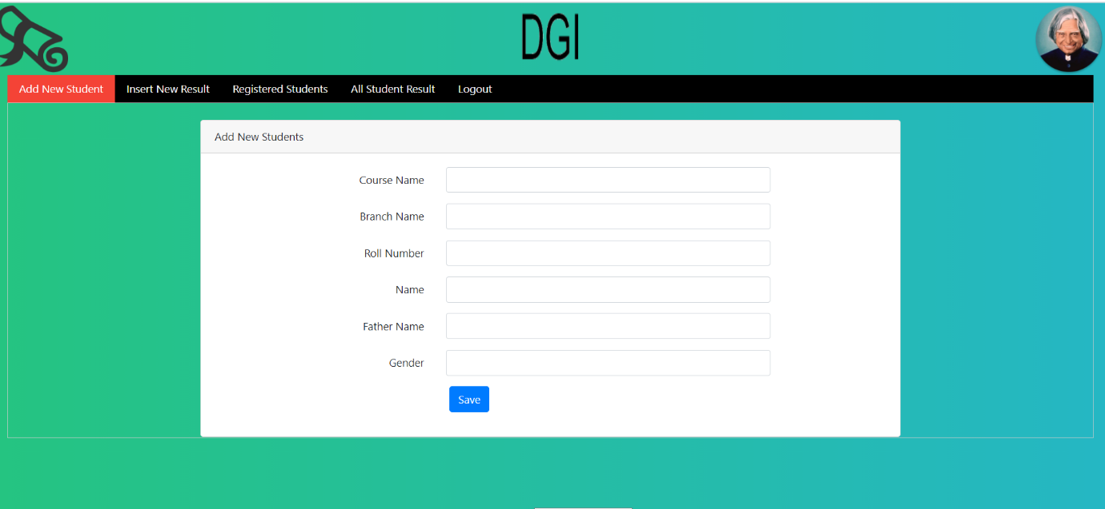

**INSERT NEW RESULT:**

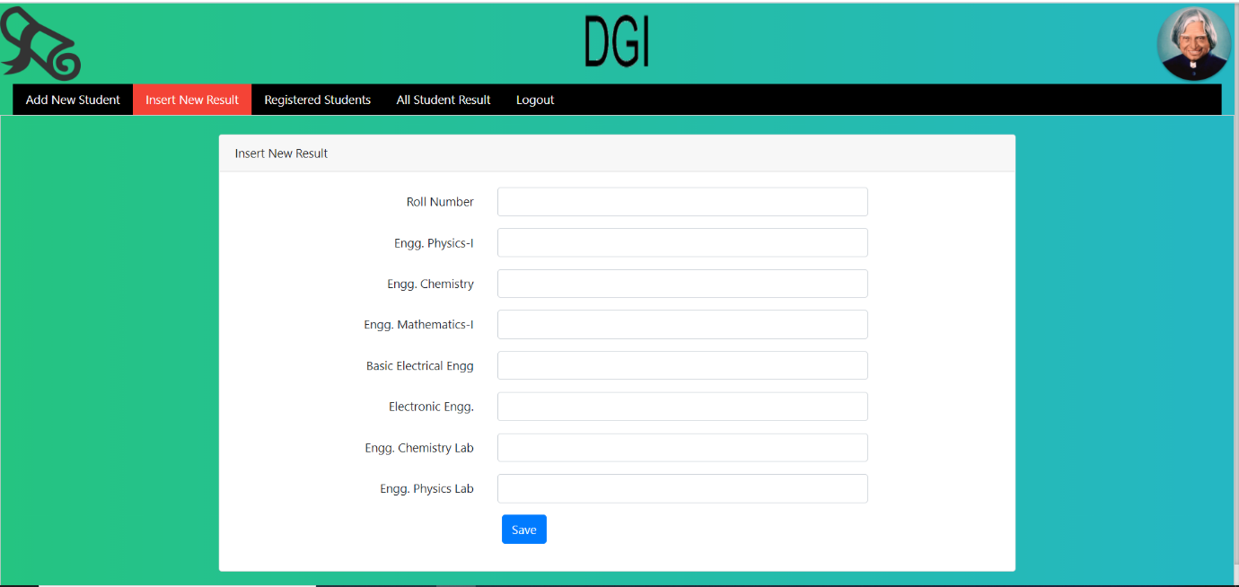

**REGISTERED STUDENTS:**

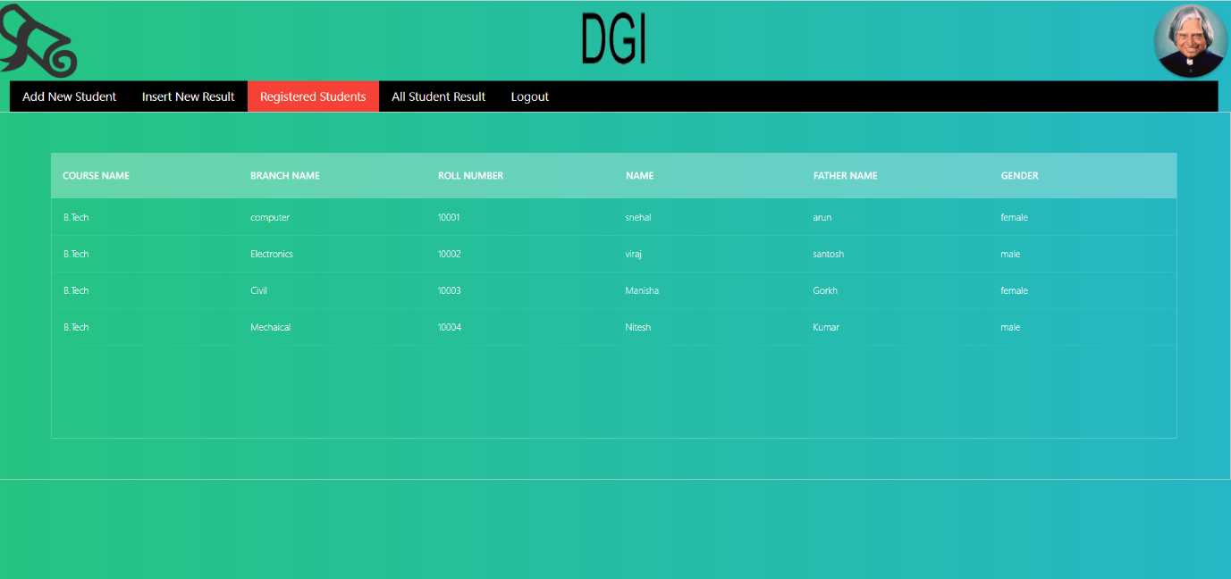

**ALL STUDENT RESULT:**

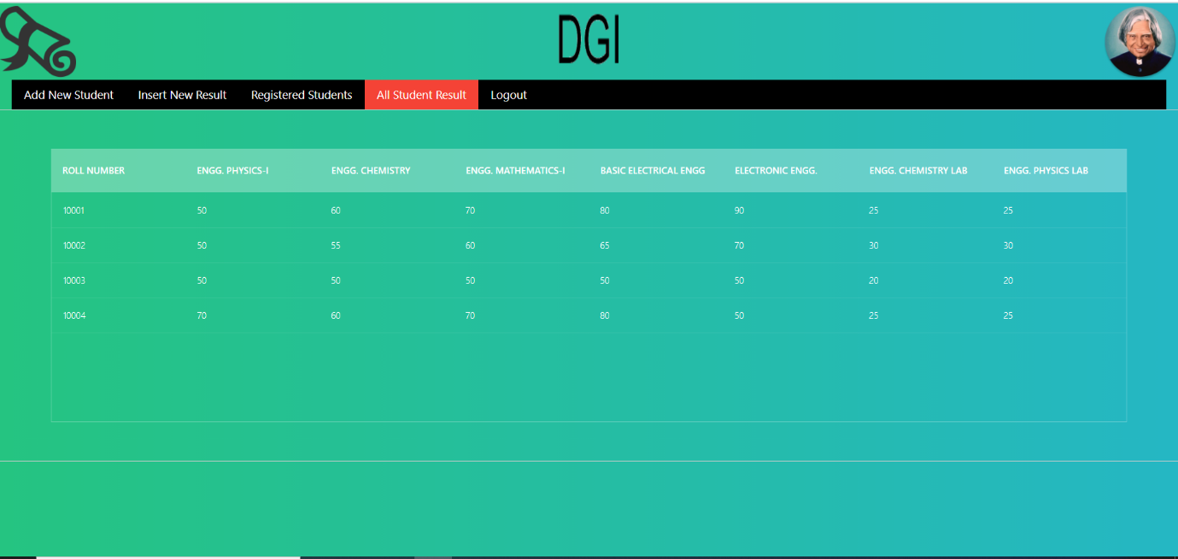

**SEARCH RESULT:**



**MARKSHEET:**

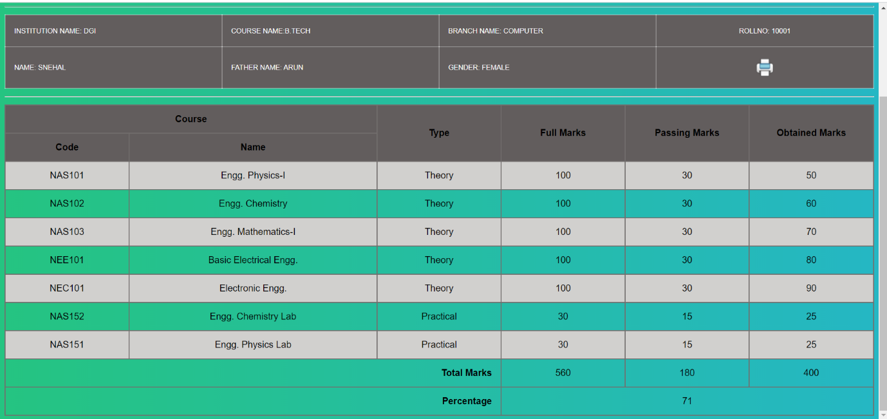

**MARKSHEET PRINT:**

